**Extended Abstract PROJ3999 (Major Project)**

**Title: DEVELOPMENT OF A SUPPORT DRONE FOR EMERGENCY SERVICES**

**Project Supervisor: Mrs.Sanhita Manna**

**Cluster Name (AI/ML, VLSI, Comm., CSP, Power Systems): CSP**

**Project Coordinator: Dr.Pankaj Kandhway**

(If Interdisciplinary, share details)

**Mini Project (PROJ2999) Outcome: (Summary in 3-6 bullet points)**

• Develop a prototype using off-the-shelf components to minimize costs.

• Implement a modular design for easy maintenance and future upgrades.

• Conduct controlled environment testing to ensure the drone’s reliability before deployment in actual disaster scenarios.

• Components such as GPS, ultrasonic sensors, camera modules, and Wi-Fi communication modules were procured and integrated into the drone’s design.

• Initial prototyping involved testing sensor integration and flight stability in a controlled indoor environment.

• Software integration focused on enabling autonomous navigation and real-time data streaming.

**Extended Project Abstract (up to 300 words)**

In an era where natural and man-made disasters are increasingly common, rapid and efficient emergency response is vital. This project focuses on developing an advanced assistance drone designed to enhance emergency services by providing real-time situational awareness and supporting rescue operations in challenging environments.

The drone integrates cutting-edge technologies, including high-resolution Full-HD imaging, GPS, infrared, and ultrasonic sensors, enabling precise navigation and seamless obstacle avoidance. It offers a flight time of up to 40 minutes within a 1-kilometer range and transmits data at 30 fps with speeds of 100 Mbps, ensuring continuous communication and coordination. Built with lightweight, durable carbon-fiber materials and equipped with redundant systems, the drone is designed to operate reliably in harsh conditions.

The development process emphasizes cost-effective modular design, extensive simulations, and controlled environment testing. Initial results demonstrate a 90% success rate in obstacle avoidance and 95% reliability in real-time data transmission. Field tests confirm the drone’s efficacy in both urban and rural emergency scenarios.

By reducing response times by up to 50% and enabling remote situation assessment, the drone significantly enhances the safety and effectiveness of emergency responders. This project contributes to advancements in UAV technology, offering a transformative solution for emergency management and disaster response, ultimately saving lives and minimizing the impact of disasters on communities.

**Extended Project Objectives (up to 2-4 Bullet points)**

* Integrate Thermal Imaging system into the drone
* Develop thermal image processing neural networks to detect image hot-spots
* Test autonomous flight systems and geo-fencing capabilities

**Ghent chart for Extended Project PROJ3999-**

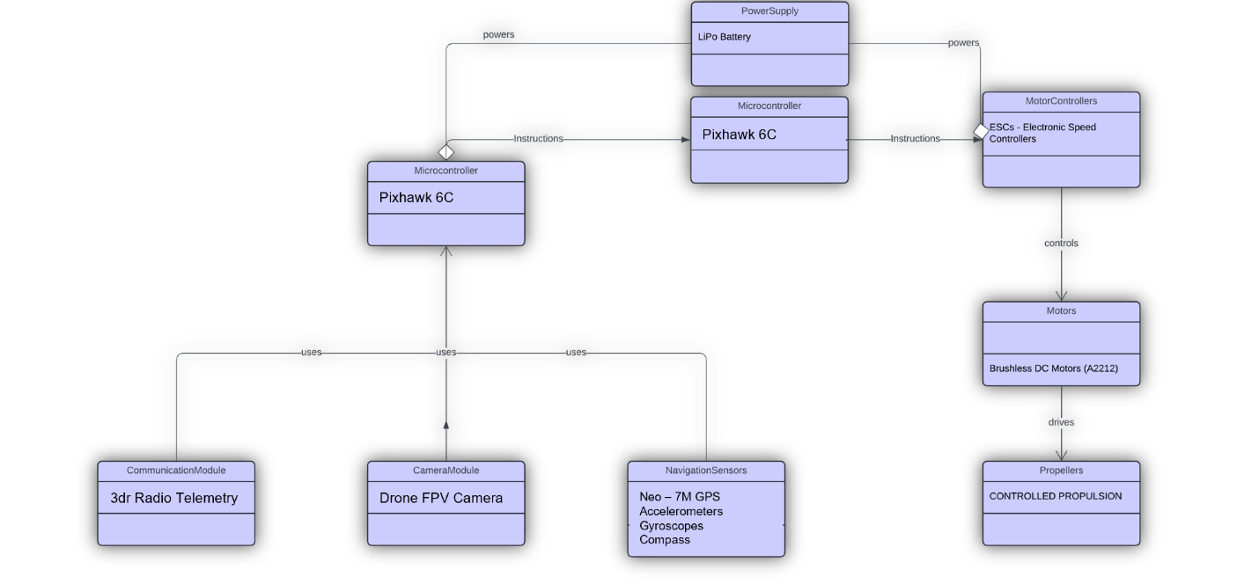

**Suggest 2 IEEE Conference targets-**

**Group Details (Reg No., Name):**

BU21EECE0100162 Jagannath Sagar Karri

BU21EECE0100086 Palakonda Visweswara Rao

(**Project Supervisor Name)**

**Sign with date**